**Literature Review**

As engineers, we are tasked to fully study a situation before engaging in any developmental and or design activities. Furthermore, to understand the current technology and innovation of our century we will conduct a literature review on three cases. Undoubtedly, these cases will cover autonomous robots and some of their uses. It should be noted that most of these cases are within the past few years. Which will give us an accurate lookout on the current technologies. On the other hand, we believe these cases might give us inspiration to lead us into some ideas for our problem solution.

**Case Study #1: Smart Drone Delivery System [1]**

With the ever-growing usage of online shopping and e-markets, the usual petrol operated vehicles that succumb to gravity is not enough to cover the demand that is skyrocketing. Consequently, the first case study published by Shivaji University in India talks about a smart drone delivery system. In this delivery system, it is proposed that a Quadcopter (QC), which is an Unmanned Aerial Vehicle (UAV), delivers orders requested through online shops autonomously by the use of Google Maps and its own processing unit. The paper also mentions “the QCs capability of delivering parcel ordered by online and

coming back to the starting place.”.

The QC’s that will be deployed should have a vertical take-off and landing protocol in order to reduce the area required for functionality. Furthermore, this will allow the QC’s to function in small neighborhoods and streets which many cramped cities have. A 10–15-mile radius can be covered by a single QC. In addition, the vertical approach to these QC’s allows them to carry more payload, this in turn will yield better results for the online shops.

A basic working principle for the QC’s was stated in the paper. A total of four rotary motors at equidistance from each other and a central driver is suggested for a vertical takeoff/landing protocol. To be clear, this configuration functions in a specific way. As such, opposite rotaries spin in opposite directions while adjacent ones function similarly. Using this design, any gyroscopes controlling the QC’s is not needed.

Finally, the methodology for delivering the shipments is as follows; The processing unit of the QC’s, which is a raspberry pi, is interfaced with a camera, video streaming, SD card and GPS. When an order is placed, all these technologies work together to find the correct address of the house and deliver the shipment. Below is a figure that showcases the order of operations.

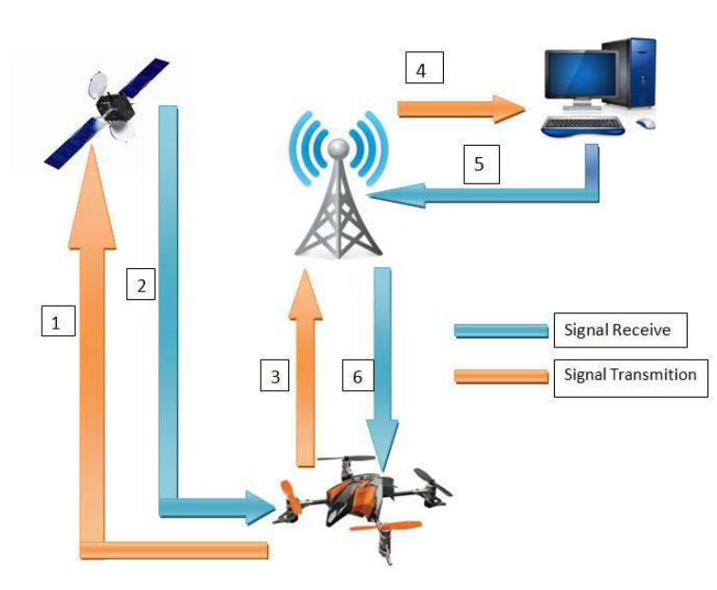

Figure Showcases the order of operations the QC's follow

**Case Study #2: Prototype design of medical round supporting robot “Terapio” [2]**

In this case study, the main focus is a robot that is implemented inside an important ecosystem. Terapio is a medical assistant autonomous robot that will revolutionize the healthcare scene. Its main functions are to deliver armamentarium and provide health care data to the doctor. Whether it be a scalpel, a syringe or even a dental kit, this robot can fetch and receive any equipment a doctor need. Furthermore, the robot has the medical history of the patient and can assist the doctor in evaluating a patient’s needs. The robot boasts an internal storage and object detection which can prove to be helpful in navigating the hospital hallways that are clustered with personnel and objects.

Fascinatingly, the robot has three main modes of operation. First, human tracking mode. The robot follows the specified doctor and accompanies him wherever he goes. This mode is useful for the doctor since he does not have to worry about carrying the robot around. Second, Power assisting mode is where the robot can hold the patient, hold a tool or even detect force specified by the doctor. To explain, a dentist might need a tool to be held in a specific way to access a wisdom tooth. The robot can hold the tool precisely and accurately. This in turn can reduce the burden on the dentist and allow him to complete the surgery effectively. Finally, the round mode is an interesting mode. The robot listens to the consultation and records it. Furthermore, the robot denotes everything and organizes it for the doctor for later use. An extra feature of the robot is its facial expressions. These facial expressions help reduce the emotionless of the robot which in turn can increase the healing of patients via emotions. Below is a figure representing the modes of Terapio

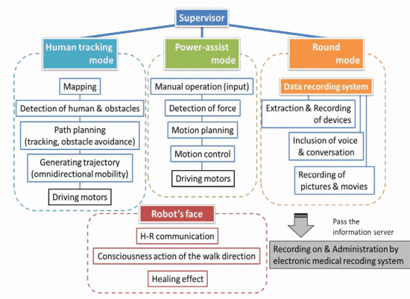

Figure showcases Terapio's modes

REFERENCES LATER MAKE THEM PRETTY

<https://www.researchgate.net/publication/344513432_Smart_Drone_Delivery_System>

https://ieeexplore.ieee.org/abstract/document/7139274